**Name : SHWETA BANAGD CWID: A20392438**

Contents

PHASE 0: 2

1. Members and their functions in the Data Team: 2

PHASE 1: 3

1. Questions to be asked to the client to full fill business requirements by data team: 3

2. Unique Business rules: 3

PHASE 2: 4

1. Conceptual Model: 4

PHASE 3: 5

1. Logical Model: 5

PHASE 4: 6

1. Business Analytics: 6

# PHASE 0:

### Members and their functions in the Data Team:

|  |  |  |
| --- | --- | --- |
| **NAME** | **ROLE** | **FUNCTIONS** |
| Shweta Bangad | Data Scientist | Works on large data sets and understands math and statistics behind the models and can explain model behavior, it employs techniques. Has strong SQL knowledge and programming language |
| Vaishali Dhiman | Data Analyst | Collects the data and processes and performs statistical analysis and helps to improve the business decisions. This means data analysts must have great visualization and communication and great knowledge about databases. |
| Arya Sarada | Data Architect | Data Architects are the contemporary data modeler who has in depth knowledge about database architectures, have skills in data warehousing. |
| Pushkar Mehendale | Data Engineer | Data Engineers develops, tests, constructs and maintains data architectures. Must know APIs, ETL tools, database system of the company, data warehousing solutions and data modeling. |
| Nazim Udasi | Database administrator | Database administrators makes sure that all data is available to relevant users and data must be secured at the same time. They make sure data is maintained properly like recovery and backups, data security and must have business knowledge. |
| Suyash Dewangan | Predictive Analytics developer | Predictive Analytics developer are used in organization to predicts the behavior of consumers and to target people who use this product. They make assumptions from the history of data performance and predict the future performance. |

# PHASE 1:

### 1. Questions to be asked to the client to full fill business requirements by data team:

1. Who will approve the travel advance request submitted by sales person?
2. Before how many days should salesperson request for travel advances?
3. Who will manage all the procedures and closures of file after travel expense is submitted by salesperson?
4. Do you want multiple categories of expense in the expense report or only the total expense?
5. What all expenses will be covered in travel advances check?
6. By what time the expense report must be submitted by the salesperson?
7. Can there be more than one sales person for one event?
8. What must be done about the travel advance check, in case of event cancellation?
9. What should be done if expense amount exceeds the travel advance amount?
10. What should be done if expense amount is less than travel advance amount?
11. What should be the maximum amount requested by the salesperson?

### 2. Unique Business rules:

1. The travel advance requests will be approved by an accountant and will at least take 10 days to get approved.
2. The travel advance will only cover the ticket, taxi, accommodation and food expenses other than this expenses will be personal expense.
3. For a single event, there can be many salespersons who will be given travel advances.
4. The status of Event will help to conclude if the event is still going on or is closed or is cancelled.
5. If the event is cancelled, then all the checks issued by that event must be returned to the accountant.
6. If the expenses amount exceeds the travel advances, then the accountant have to give the difference amount in the form of check to the salesperson.
7. If the expense amount is less than the travel advances, then the sales person has to give the remaining amount in the form of cash or money to the accounting department.
8. The expense report will only cover the Ticket fare, taxi fare, lodging expenses and meal expenses which each sales person has to enter the amount he expensed on the travel event on particular category.
9. And the total of all the ticket fare, taxi fare, lodging expenses and meal expenses will be shown in the expense report.
10. The sales person must submit the expense report after the event is concluded with the list of expenses that were incurred during travel event.
11. The salesperson must always choose a minimum fare for everything like for ticket fare he must choose the least expensive ticket that is economical ticket rather than business class, for lodging he must find the lodges that are cheaper rather than 5 star hotels.

# PHASE 2:

### Conceptual Model:

Here is the conceptual model that defines the entities and the relationship between them for the travel advance/ expense report system.

Entities:

1.**Accounting_dept**: This entity will show all the information about the accountant who will approve and do the procedure in the company about travel advances.

2. **Salesperson**: This will store the information about the salesperson-name, email, id.

3. **Events**: This stores the information about events- its description(name), status if active cancel or closed.

4. **Travel_advances**: This entity will store all the information about the travel advance given, how much amount for which sales person, travelling city, date of issue, issued by which accountant for which event.

5. **Expense_report**: This entity will give the report about the total expense done by the salesperson in an event, the date on which report is submitted.

6. **Expense_category**: This entity helps to know the particular expense done on each like ticket, taxi, hotel and food.

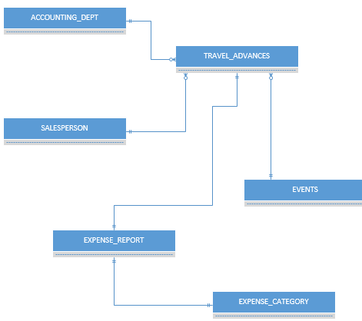

# PHASE 3:

### Logical Model:

Here is the logical model which defines the entities, their attributes and the relationships between them for the travel advance/expense report system.



# PHASE 4:

### Business Analytics:

Few business analytics that can be done based on this database scenario are:

1. From the database, we can know how many salespersons are going on a travel event per month.
2. We can also infer from data that how much expense is done by the salespersons on travel event and per that the company can decide what should be the minimum travel advance given.
3. We can also know that which accountant is managing the most travel advance records.
4. We can get a report at the end of a month which will let us know about the total expenditures happening on travel events in the company.
5. We can also infer from the database about the rate of cancellations, active and closed events.
6. From the database, we can also know about the expenses done on food, ticket, taxi, and hotel in particular by the salesperson.
7. We can also find out the number of sales person who submit the expense report in time.
8. We can also analyze that how many salespersons exceed the amount of travel advances given to them.
9. We can also analyze the number of salesperson whose expenses were less than the given travel advances.
10. We can also analyze, for which event salesperson travel the most.
11. We can also analyze the most travelled city by the sales persons for the sales purchase events for the company.